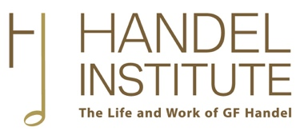

Application for Handel Institute Conference Award
Handel Institute Conference Awards are intended to help individuals attend a conference to read a paper or present a poster on a Handel-related subject that has already been accepted by the conference organisers.
Applications must be submitted before expenditure is incurred, and preference will be given to postgraduate students and early-career academics.
Please e-mail the completed form to helen.coffey@open.ac.uk. The annual deadlines for applications are 30 April, 31 August and 30 November.

PERSONAL DETAILS

Name:

E-mail address:

Present appointment/university affiliation (if any):

Name and date of conference for which funding is requested:

Funding requested/received elsewhere:

FUNDING REQUIRED
Please provide a breakdown of the proposed expenditure (in pounds sterling) that would be funded by the Handel Institute. Please add lines to the table below where necessary.

Item | Details | Proposed  Expenditure
Travel
Accommodation
Conference fee
Other - please specify
 |  | Total requested (£)

CONFERENCE ABSTRACT
Please provide the abstract of the paper to be presented at the conference named above.

PROOF OF ACCEPTANCE
Please provide evidence that your paper has been accepted for the above-named conference (for example, an image of or link to the relevant page from the conference programme, or the e-mail confirming acceptance of your paper).

