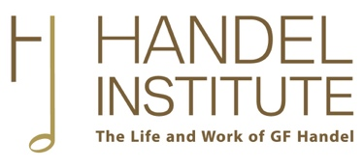

Application for Handel Institute Research Award
Applications are invited for Handel Institute Research Awards in support of a research project relating to the music or life of George Frideric Handel or to any individual, group or institution with whom/which he was associated.
No single award will exceed £2,000. The Institute encourages applications from any student or scholar, regardless of age or background. Awards will not be made for the payment of university or college fees.
Please e-mail the completed form to helen.coffey@open.ac.uk. The annual deadline for applications is 30 November.

PERSONAL DETAILS

Name:

E-mail address:

Qualifications and/or appointments:
Please list your most recent relevant qualifications and/or appointments, from the past 5 years.

Total funding requested:

Funding requested/received elsewhere for the same project:

RESEARCH PROJECT OUTLINE

Aims and context (maximum 350 words)
Please provide the justification for your proposed project by outlining its main aims and scholarly context, including references to relevant literature.

Plan of action and justification of expenditure (maximum 250 words)
Please outline here how you plan to conduct the project outlined above, stating clearly why Handel Institute funding is necessary for you to be able to undertake these activities.

Planned research outputs (maximum 150 words)
Please describe and/or list the main outputs planned for the above research (e.g. details of any dissertation, article(s), monograph(s), conference paper(s) to which the research will contribute).

TIMING
Please list the date, location and nature of each research activity that would be funded by the Handel Institute (add extra lines if required).

Date | Activity | Location

FUNDING REQUIRED
Please provide a breakdown, in pounds sterling, of the proposed expenditure that would be funded by the Handel Institute. Please add lines to the table below where necessary.

Item | Details | Proposed  Expenditure
Travel
Accommodation
Scans/photocopies
Other ̶ please specify
 |  | Total requested (£)

ADDITIONAL COMMENTS
Please provide any further information that you wish the Handel Institute to take into account when assessing your application.

REFERENCES
Please ensure that two references are e-mailed to helen.coffey@open.ac.uk by the application deadline.

